My feeling is that this is an extremely seller-centric firm with strong engineering culture.

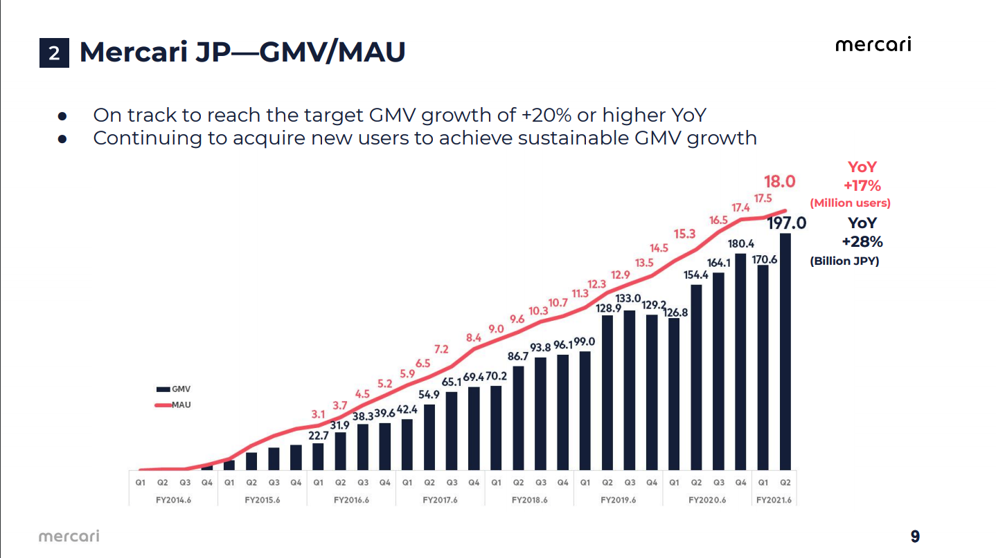

*Source: FY21Q2 Presentation*

18m MAU JP

197B JPY GMV

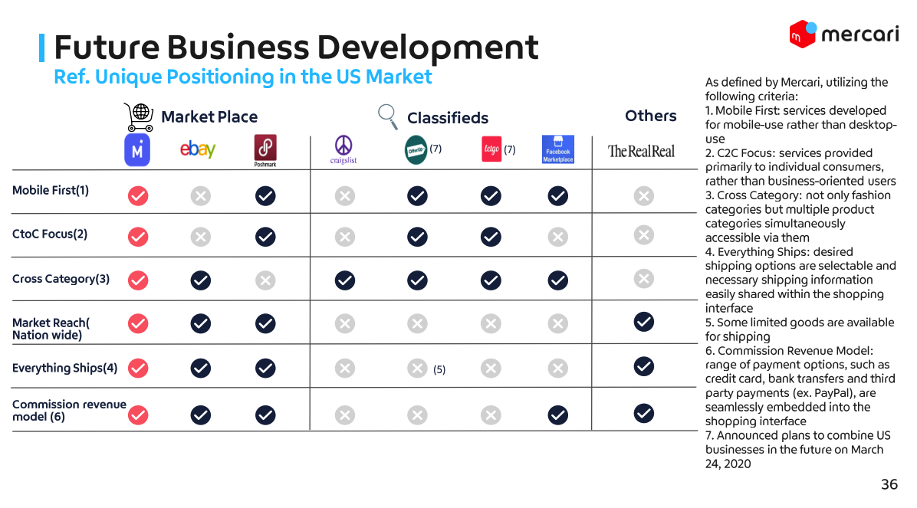

*Source: Factbook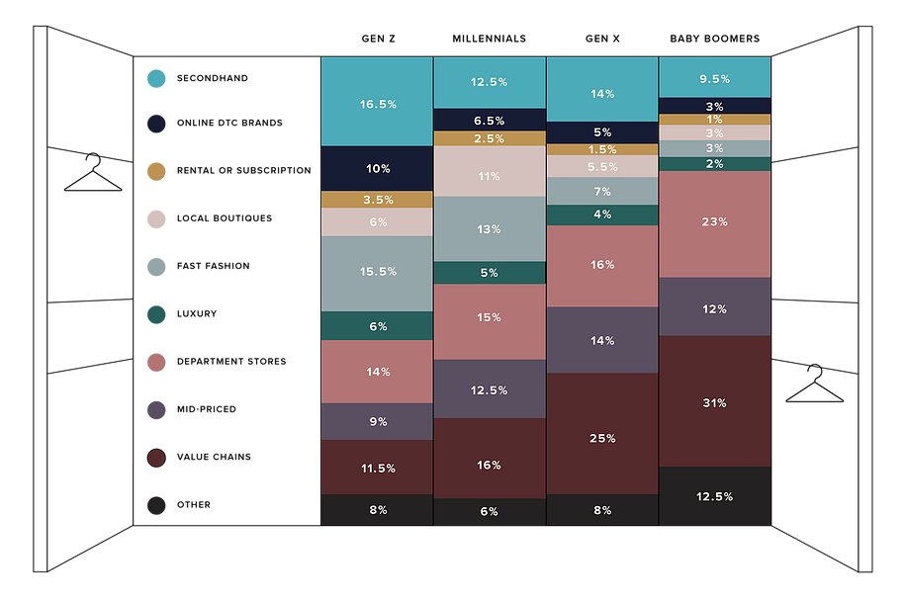*

**Questions:**

Take rates history

Seasonality for secondhand market?

Not so much, according to Posh’s financials. That means Q4 decline is a company-specific phenomenon.

How does the company make money?

Take rates, which is effectively 15% in the US (10% transaction fee + payments etc). This is below Poshmark’s 20%.

How does the company acquire sellers and buyers?

Ads, invite credits

Circular economy, how does the company plan to implement it in the US?

What is the CAC?

What is the GMV growth and multiples vs peers?

Spending habits in the US vs Japan. What differences or localizations have the company made in the US?

What is the US revenue compared to POSH?

About half

Now it’s still search and filter based model, but does the company have a roadmap to transform the product into recommendation based model like PDD?

Category mix in the US vs Japan?

Mostly women’s clothing, and toys, electronics. Women’s clothing is about 20% for each country now

Philosophy regarding capital allocation? Seems like the company wants to put every dollar in gains back to the business.

How have you learned from EU business and adapted for the US business?

**Links**

<https://www.getrevue.co/profile/plantmath1/issues/mercari-deep-dive-investment-thesis-361814> - Investment writeup

<https://www.japantimes.co.jp/news/2020/02/20/business/corporate-business/mercari-first-physical-store/> - Mercari Station

<https://about.mercari.com/en/press/news/articles/mercari_conference/> - Mercari 2020 Conference

<https://pdf.irpocket.com/C4385/y7if/M1Gl/lVMJ.pdf> - 2018 growth initiatives

<https://speakerdeck.com/mercari_inc/mercari-fact-book-en?slide=63> - Factbook by Mercari Aug 2020

<https://pdf.irpocket.com/C4385/HTFv/KxNM/wZC1.pdf> 2021 Q2 report (CY2020 4Q)

<https://d18rn0p25nwr6d.cloudfront.net/CIK-0001825480/3eb3bf3a-8f08-4474-8d31-243a8aee570e.pdf> Poshmark S1

<https://www.report.poshmark.com/#:~:text=METHODOLOGY,a%20research%20and%20analytics%20firm.&text=Poshmark's%20Social%20Commerce%20Report%20also,community%20of%2060%20million%20users>. - Poshmark social ecommerce report

**Plant Questions:**

1) I would love any information regarding a US listing.

2) Plans regarding Merpay for financial services outside of Mercari like P2P payments (like Venmo, Cash App, etc) and investing products (stocks) outside of the Funds test.

3) Are they noticing any change in the trajectory of the US business now that COVID has become more stable.

4) How are they expanding customer service in the US, there have been reviews stating people cannot reach an agent.

Q4 US slow down thesis: because of the rate hike

First, what rate hike are we even talking about here?

ok , the introduction of payment processing fee of 2.5%.

However, the company mentioned that they have not seen any negative impact coming from this decision.

What about Poshmark? Did they experience slowdown in Q4?

Seems like analysts are projecting slowdown in Q4. My hypothesis is that during the holiday season people want to make fresh purchases, which means consumers spend more on brand new stuff, especially for clothing (Black Friday, etc, made brand new merchandise available at discount).

What is the S&M spend in the US?

Will ask management

**To do:**

* map out MAU and GMV and compare that with CEO decisions

**Valuation (Rough)**

Valuation-wise this is not a good investment. The upside is very limited even with the optimistic assumption.

**Lessons learned so far:**

Oversimplifying valuation. Not all technology firms can be valued on EV/Sales. Cash is the king at the end of the day.

**Call with IR**

**Intro**

We are snowpeak securities, a hedge fund based in New York. We do long-only investments and have the ability to invest worldwide.

I’m a portfolio manager at the firm and Amy is another PM covering specifically Asian securities.

**Questions:**

1. Are they noticing any change in the trajectory of the US business now that COVID has become more stable.
   1. How’s John Lagerling - Senior Vice President / CEO of Mercari, Inc. (US) doing?
      1. Decision making process

50% for this year

Initiatives- meeting every months

Startup in US - invest in the US rather than running it from Tokyo

US 1/6th in japan.

1. What is the priority among Japan, Merpay, US, and Souzoh (more on this)?
   1. Plans regarding Merpay for financial services outside of Mercari like P2P payments (like Venmo, Cash App, etc) and investing products (stocks) outside of the Funds test.

JP funds other businesses

Souzoh - starting

Merpay: planning strength in credit, consumer. Dont think be

Subsidies to JP players

1. Philosophy regarding capital allocation? Seems like the company wants to put every dollar in gains back to the business. Where are they re-investing their money?
   1. Can the integration between primary and secondary distribution be replicated in the US? <https://about.mercari.com/en/press/news/articles/mercari_conference/>
      1. How has this been playing out in Japan?

Eventually to the US

* 1. For the US operations, how does the company budget mostly for promotions (marketing)?
  2. ~~Now it’s still a search and filter based model, but does the company have a roadmap to transform the product into a recommendation based model like PDD?~~

1. How are they expanding customer service in the US, there have been reviews stating people cannot reach an agent.

Deems it important.

Not grabbing market share

1. I would love any information regarding a US listing - ADR

Al business - invest in mkting

1. Who would you recommend me to reach out to to learn more about the US operations?

100M GMV - BE point

1. コロナウイルス​の発生から1年たった今、メルカリの営業に変化はありましたか?

2. メルペイ​、アメリカ、想​像​、で優先順位とはは考えていらっしゃいますか？

3. メルカリはどのような形で資本をどのようなビジネスに再投資していますか?

a. 一次配布と二次配布の統合をアメリカで複製予定は?これは日本でどのように機 能しましたか?

b. アメリカ事業の場合、貴社は主にマーケティングのためにどのように予算を組ん でいますか?

c. メルカリは引き続き検索およびフィルターベースのモデルで動作しますが、PDD のような推奨ベースのモデルに実装する計画はありますか?

4. アメリカで貴社の方針としてカスタマーサービスをどの様に考えていますか？

お客様の質問に答えていないというレビューがあります。

5. アメリカのリストに関する情報があれば、貴社助けになりますか？

6. アメリカの事業についてもっと知る為にアドバイスはありますか？